CERTIFIED TRANSLATION
Front Side

Original document contains the holder’s photograph | Driving License | Islamic Republic of Iran  Traffic Police Emblem

First Name: |  | Last Name:
National ID No: |  | Date of Birth:
Driving License No.: |  | Serial No:
Date of Issue: |  | Date of Expiry:

Law Enforcement Forces of the I.R. Iran
Head of Traffic Police
Name and Surname: Signature
Back side

Status | Initial Date of Issuance of Driving License | Vehicle Categories |  | Driving License Classes
Authorized since |  | $$≤250CC$$ |  | Motorcycle  A - AM
Authorized since |  | <8+1 Person,< 3500 kg |  | Third Class  B – B1
Authorized since |  | 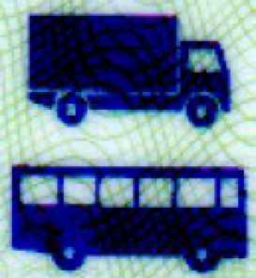 $<25+1Person;≤60000k.g$ |  | Second Class  C1 – D1
Authorized since |  | 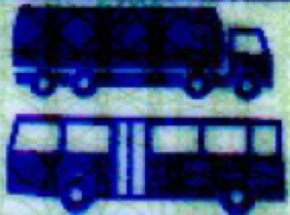 $≥26Pesron;>60000k.g$ |  | First Class  C – D - CE
***** | ***** |  |  | Özel
Special Driving Restrictions: | ***** |  |  | Blood Group:: AB+
BARKOD: QR code

*_*_*_*_*_*_*_*_*_*_*_*_*_*_*_*_*_*_*_*_*_*_*_*_*_*_*_*_*_*_*_*_*_*_*_*_*_*_*_*_
This translation has been made in accordance with the original Persian document submitted to me.
Tehran, …..
File No.: ….

